Mobile Application Development Report

on

UDEMY COURSES ANALYSIS
Submitted By
Under the Guidance of
TY AI&DS– B(53)
Koshal Bonde

Ifat Sheikh
T. Y. Artificial Intelligence and Data Science (2025-2026)




Department of Artificial Intelligence and Data Science
K. K. Wagh Institute of Engineering Education & Research
Hirabai Haridas Vidyanagari, Amrutdham, Panchavati,
Nashik – 422 003

Abstract

The Udemy Courses Analysis Dashboard presents a concise overview of course performance, revenue generation, and student engagement across various subjects. It highlights key metrics such as total revenue, total students, course count, and average course price to provide a quick business summary. The analysis shows that web development contributes the highest revenue compared to other categories like business finance and graphic design. It also examines student distribution based on payment methods, indicating a strong preference for digital transactions. Course levels are analyzed to understand learner demand, with “All Levels” and beginner courses attracting the majority of students. The relationship between number of lectures and content duration is visualized to study course structure patterns. Year-wise price trends indicate a steady increase in course pricing over time. Interactive filters such as quarterly selection and payment type improve user-driven analysis. The dashboard enables better understanding of market trends and learner behavior. It supports data-driven decisions for pricing, content planning, and course optimization.
Keywords: Udemy, Course Analysis, Data Visualization, Revenue Analysis, Student Engagement, Payment Methods, Course Levels, Pricing Trends, Dashboard, Business Intelligence


Table of Contents

Sr. no | Topics | Page No
1 | Introduction | 4
2 | Problem Statement | 4
3 | Objectives | 4-5
4 | Figma /UI | 6
5 | Screenshots | 7-8
6 | User Manual | 8
7 | Conclusion | 9
8 | Link to the project | 9
9 | Appendices | 9

Introduction

Overview of the project

The Udemy Courses Analysis Dashboard is a data visualization project designed to analyze course performance and user engagement on the Udemy platform. The dashboard uses interactive charts and filters to simplify data exploration and highlight key patterns.

Brief Summary

It provides insights into revenue, student enrollment, pricing trends, and course distribution across different subjects. A detailed scatter plot correlates the number of lectures with content duration, offering insights into course structure and its impact on engagement. Temporal trends are captured through yearly price analysis, indicating a steady growth in course pricing over time.

Problem Statement

Definition of the Problem

To design and implement an interactive Udemy Courses Analysis Dashboard for visualizing key metrics.The system aims to convert complex educational data into meaningful insights using intuitive visualizations and filters.

Objectives

  - To analyze course performance based on revenue, students, and categories.

  - To visualize data using interactive charts and filters.

  - To identify trends in pricing and learner preferences.

Outcomes

  - Clear insights into high-performing courses and categories.

  - Improved understanding of student behavior and payment trends.

  - Better decision-making for course design and pricing strategies.
.

Background

Tools and Technologies
  - Power BI – for data visualization and dashboard creation
  - Microsoft Excel – for data cleaning and preprocessing
  - DAX (Data Analysis Expressions) – for calculated measures and KPIs
  - Data Modeling – to establish relationships between datasets
  - Data Visualization Techniques – for charts, graphs, and insights generation

Software and Hardware Requirements
- Power BI Desktop
- Mircrosoft Excel
- Kaggle dataset

Figma (Architecture if any )

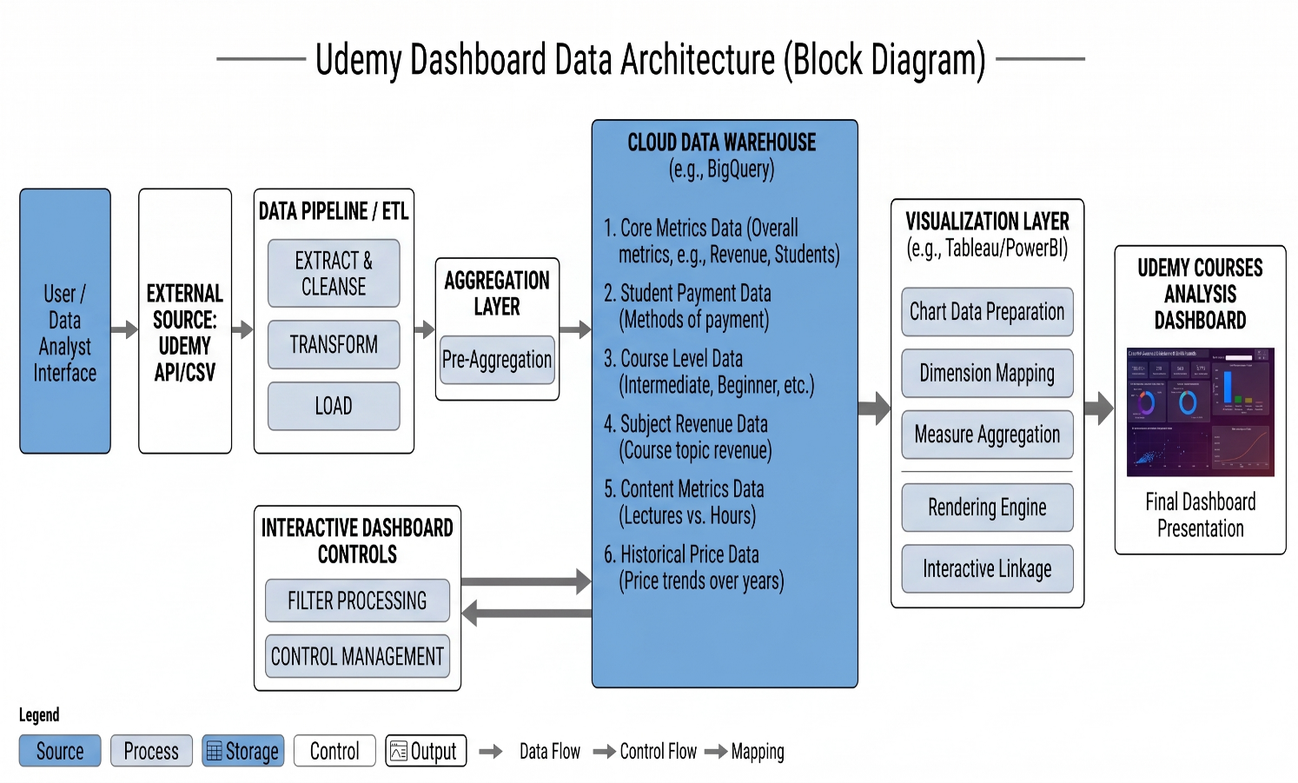

Screenshots of the project

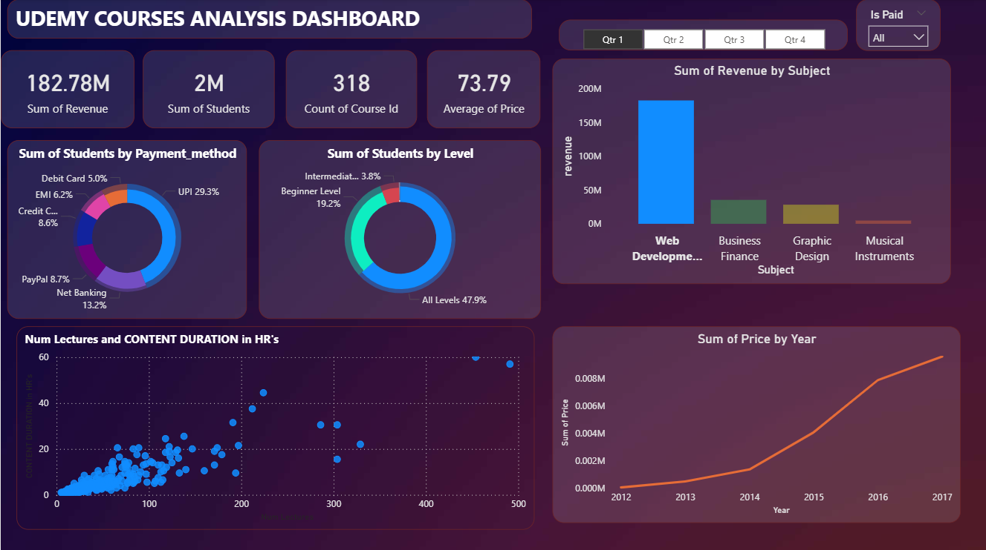

User Manual

Open the dashboard in Power BI Desktop or Power BI Service to view the main summary page.

Review the KPI cards at the top to understand total revenue, students, courses, and average price.

Use the Quarter slicer to filter data based on specific time periods.

Select different Payment Types from the slicer to analyze transaction preferences.

Hover over charts and graphs to view detailed tooltips and exact values.

Click on any bar, pie slice, or data point to apply cross-filtering across the dashboard.

Analyze subject-wise revenue distribution using the bar chart for category comparison.

Explore course levels (Beginner, Intermediate, All Levels) to understand learner demand.

Use the scatter plot to examine the relationship between lectures and course duration.

Reset filters or clear selections to return to the default dashboard view for a fresh analysis.

Conclusion
The Udemy Courses Analysis Dashboard provides a clear and structured view of course performance and learner behavior. It effectively highlights key trends in revenue, pricing, and student engagement across different categories. The use of interactive visualizations makes data exploration simple and insightful. It helps identify high-performing courses and understand user preferences. Overall, the dashboard supports informed decision-making for improving course quality and business outcomes.
Analysis:
- The dashboard reveals that web development courses generate the highest revenue and attract the most students.
- It highlights trends in pricing and learner preferences, showing higher demand for beginner and all-level courses.
User Impact:
- Enables users to quickly understand course trends and make informed decisions.
2. Provides Improves user experience through interactive and easy-to-use visualizations.
Technical Performance:
- Ensures efficient data processing and fast dashboard responsiveness.
- Utilizes optimized data modeling and DAX calculations for accurate insights.
Recap of Results
- Functional Deliverables
  - The dashboard successfully visualizes key metrics like revenue, students, and course distribution.
  - Web development emerges as the top-performing category in terms of revenue and engagement.
- Analysis Engine
  - Beginner and all-level courses show higher demand among learners.
- User Dashboard
  - Consistent system performance with structured and meaningful output
  - Interactive filters enhance data exploration and better decision-making.

Link of the Project (Github)

Udemy - dashboard

- Appendices
  - Presentation Slides (PPT)
  - Course Completion Certificate

